Parte superior do formulário

Pergunta 1: **Incorreto**

An IT Engineer needs to create a Virtual Machine in Azure. Currently, the IT Engineer has an Android OS based workstation. Which of the following can the IT Engineer use to create the desired Virtual Machine in Azure? **[SELECT THREE]**

* 

**A. Microsoft PowerApps**

**(Incorreto)**

* 

**B. Azure Cloud Shell**

**(Correto)**

* 

**C. Azure Powershell**

**(Correto)**

* 

**D. Azure CLI**

**(Correto)**

**Explicação**

**Answers: B, C, and D**

On an Android OS, one can go to the Portal and launch Azure Cloud Shell as shown below.

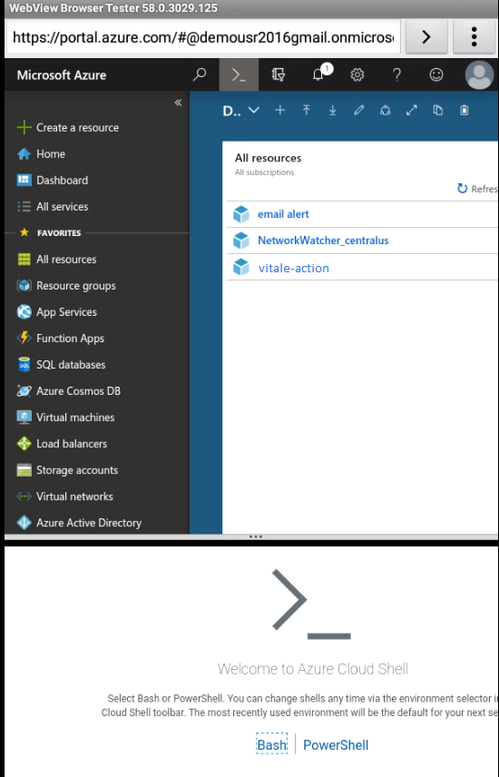

Option A is incorrect since PowerApps would not be used to create Virtual Machines.

Remaining All Options are Correct i.e. B, C and D are correct.

The Azure mobile app allows you to choose your preferred CLI experience between Bash and PowerShell. So the answer is Cloudshell + Powershell.

The Azure mobile app comes with Cloud Shell integration. You can execute commands and use your saved scripts giving you an unparalleled ability to control your Azure environment anywhere.  
**The Azure mobile app allows you to choose your preferred CLI experience between Bash and PowerShell.**  
  
**https://azure.microsoft.com/en-in/blog/azure-mobile-app-now-generally-available/#:~:text=The%20Azure%20mobile%20app%20allows,experience%20between%20Bash%20and%20PowerShell.**

<https://azure.microsoft.com/en-us/features/cloud-shell/>

Parte inferior do formulário

Parte superior do formulário

Pergunta 2: **Incorreto**

Which of the following are true regarding the services offered as part of “Azure Germany”? Pick 2 options from the given list.

* 

**A. Azure Germany is a physically isolated instance of Microsoft Azure. It uses world-class security and compliance services that are critical to German data privacy regulations for all systems and applications built on its architecture.**

**(Incorreto)**

* 

**B. Can be used by all customers globally**

* 

**C. All customers who reside in the EU**

**(Correto)**

* 

**D. All customers who intend to do business in the EU**

**(Correto)**

**Explicação**

**Answer: C and D**

This is mentioned in the Microsoft documentation.

Azure Government is a cloud environment specifically built to meet compliance and security requirements for the US government. Azure Government applies to government at any level — from state and local governments to federal agencies including Department of Defense agencies.

The key difference between Microsoft Azure and Microsoft Azure Government is that Azure Government is a sovereign cloud. Azure Government delivers a dedicated cloud enabling government agencies and their partners to transform mission-critical workloads to the cloud. Azure Government uses physically isolated data centers and networks (located in the U.S. only).

Since this is mentioned, other **options C & D are incorrect**.

For more information on Azure Governement, please visit the below URL-

* [What is Azure Government](https://docs.microsoft.com/en-us/azure/germany/germany-welcome)
* [Azure Government Documentation](https://docs.microsoft.com/en-in/azure/azure-government/)

Parte inferior do formulário

Parte superior do formulário

Pergunta 3: **Incorreto**

A company is planning to set up an Azure Free Account. Does the Standard Support plan come along with the Azure Free Account?

* 

**A. Yes**

**(Incorreto)**

* 

**B. No**

**(Correto)**

**Explicação**

**Answer: B**

The basic support plan is the default one which is associated with all Azure accounts. To have a Standard Support Plan, it needs to be purchased.

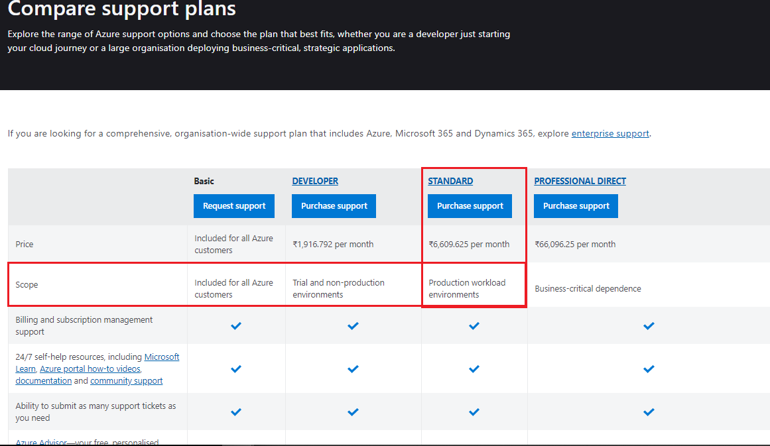

For more information on the comparison of Support plans, please visit the below URL-

<https://azure.microsoft.com/en-us/support/plans/>

Parte inferior do formulário

Parte superior do formulário

Pergunta 4: **Incorreto**

A company is planning to use its Azure Free Account for hosting production-based resources. Does the Azure Free Account allow you to host production-based resources?

* 

**A. Yes**

**(Correto)**

* 

**B. No**

**(Incorreto)**

**Explicação**

**Answer: A**

Yes, you can, although you need to understand that you will need to pay for any extra charges that don’t come under the Free Account conditions.

This is also mentioned in the Microsoft documentation.



For more information on the Azure Free Account, please visit the below URL-

<https://azure.microsoft.com/en-us/free/free-account-faq/>

Parte inferior do formulário

Parte superior do formulário

Pergunta 5: **Correto**

Your company is planning to use Azure AD for the authentication of the resources defined in Azure. Does Azure AD have the capabilities to implement authorization using Azure RBAC to secure resources?

* 

**A. Yes**

**(Correto)**

* 

**B. No**

**Explicação**

**Answer: A**

For authentication, there are multiple ways to secure the sign-in process. As shown in the Microsoft documentation below, you can use additional security options such as Security questions, Multi-Factor authentication, etc.

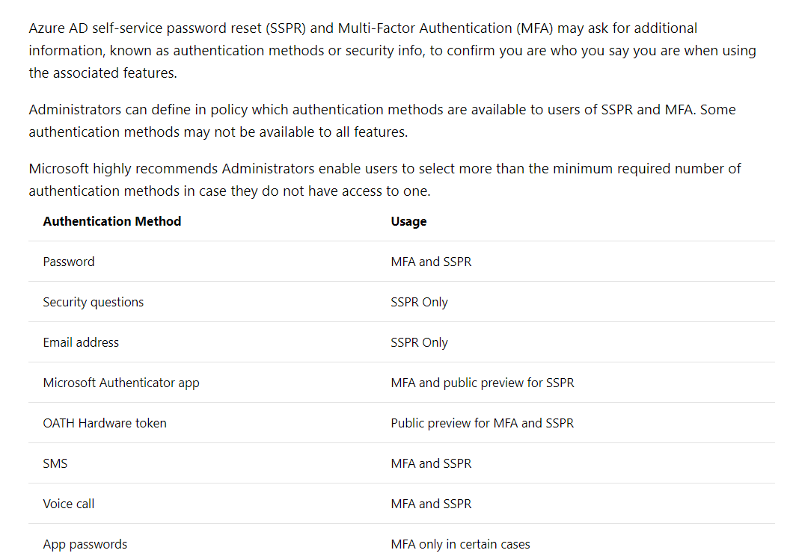

For authorization, you can use the various roles available in Azure. Below is the concept behind Role-based access control in Azure.

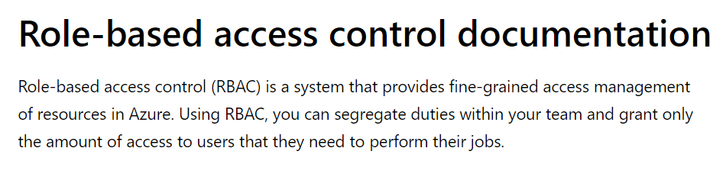

For more information on Role-based access control and authentication, please visit the below URL-

<https://docs.microsoft.com/en-us/azure/storage/common/storage-auth-aad#assign-rbac-roles-for-access-rights>

<https://docs.microsoft.com/en-us/azure/storage/common/storage-auth-aad-app?toc=/azure/storage/blobs/toc.json>

Parte inferior do formulário

Parte superior do formulário

Pergunta 6: **Incorreto**

A company is planning to purchase Azure AD tier Premium P2 for their Azure account. Does the Azure AD Premium P2 tier come with an SLA of any Azure AD Service 99.9%

* 

**A. Yes**

**(Incorreto)**

* 

**B. No**

**(Correto)**

**Explicação**

**Answer: B**

**SLA for Azure Active Directory Premium 2**

Microsoft guarantee **at least 99.9% availability of Azure Active Directory Premium 2.** So more than **99.9% availability is not possible.**

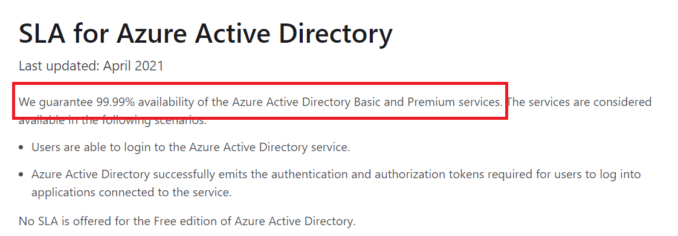

For further information refer to the below URL's.

* [SLA for Azure Active Directory | Microsoft Azure](https://azure.microsoft.com/en-in/support/legal/sla/active-directory/v1_1/)
* [SLA for Azure Active Directory Premium 1 and 2 | Azure](https://www.azure.cn/en-us/support/sla/active-directory/)
* [Service Level Agreements Summary | Microsoft Azure](https://azure.microsoft.com/en-in/support/legal/sla/summary/)

Parte inferior do formulário

Parte superior do formulário

Pergunta 7: **Incorreto**

A company plans to upgrade its current Azure AD Free plan to the Azure AD Premium P1 plan. Does Microsoft provide the same feature set for both plans?

* 

**A. Yes**

**(Incorreto)**

* 

**B. No**

**(Correto)**

**Explicação**

**Answer: B**  
  
Premium p1 has all the features that a free plan has and it will also include more features. As both, the features are not the same. **Answer is NO**

**Azure Active Directory comes in four editions—Free**, Office 365 apps, Premium P1, and Premium P2. The **Free** edition is included with a subscription to a **commercial** online service, e.g. **Azure**, Dynamics 365, Intune, and Power Platform.

**Premium P1 :**

Designed to empower organizations with more demanding identity and access management needs, the Azure Active Directory Premium edition adds feature-rich enterprise-level identity management capabilities and enables hybrid users to seamlessly access on-premises and cloud capabilities. This edition includes everything you need for information workers and identity administrators in hybrid environments across application access, self-service identity and access management (IAM), and security in the cloud.

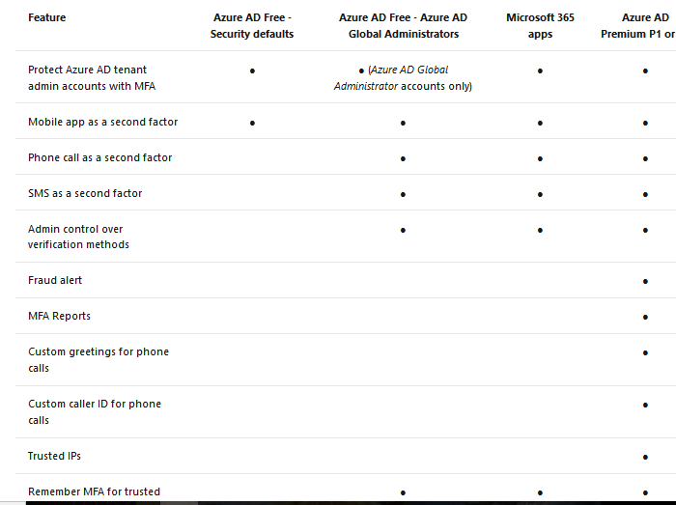

The Microsoft documentation mentions the following.

The below link provides more information about features supported in different Azure AD plans with their pricing details.

* <https://azure.microsoft.com/en-us/pricing/details/active-directory>
* <https://docs.microsoft.com/en-us/azure/active-directory/authentication/concept-mfa-licensing#available-versions-of-azure-ad-multi-factor-authentication>

Parte inferior do formulário

Parte superior do formulário

Pergunta 8: **Incorreto**

A company wants to try out some services which are being offered by Azure in Public Preview. Do the services in Public Preview in Azure come with an SLA?

* 

**A. Yes**

**(Incorreto)**

* 

**B. No**

**(Correto)**

**Explicação**

**Answer: B**

This is mentioned in the Microsoft documentation.

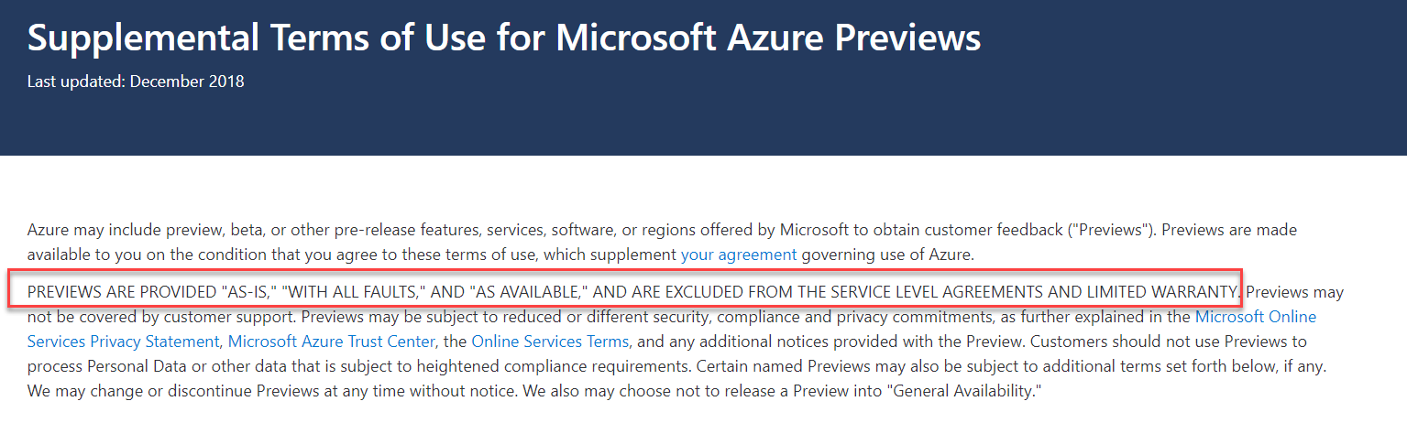

For more information on Azure services preview terms, please visit the below URL-

<https://azure.microsoft.com/en-us/support/legal/preview-supplemental-terms/>

Parte inferior do formulário

Parte superior do formulário

Pergunta 9: **Incorreto**

A company wants to try out some services which are being offered by Azure in preview. Does Microsoft provide separate portal to work with preview features?

* 

**A. Yes**

**(Correto)**

* 

**B. No**

**(Incorreto)**

**Explicação**

**Answer: A**

We can see all previews of Azure in the Azure portal only. However, there is a separate portal available (<https://preview.portal.azure.com/#home>) used for basic evaluation of preview services but not for actual use of them.  
  
With the “current” Azure Portal (http://portal.azure.com) in full force and Microsoft deprecating services/features within the “classic” Azure Portal, they have now made available a NEW Preview Portal.

The NEW Preview Portal allows you to access Azure Portal features before they are released to the main Azure Portal.

if you go to https://preview.portal.azure.com/ you can log in and experience navigation and other preview types for the portal.

<https://preview.portal.azure.com/>

https://mymicrosoftexchange.wordpress.com/2020/03/10/how-to-access-and-test-microsoft-azure-preview-features/

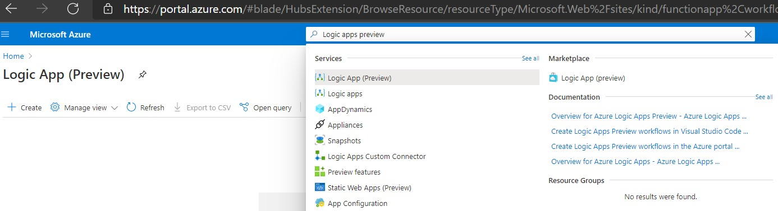

Parte inferior do formulário

Parte superior do formulário

Pergunta 10: **Correto**

Your company needs to deploy and manage several Azure Web apps using the Azure App service resource. Which of the following URL would you use to manage the Azure Web Apps?

* 

**A.**

**https://portal.microsoft.com**

* 

**B.**

**https://portal.azure.com**

**(Correto)**

* 

**C.**

**https://portal.azurewebsites.net**

* 

**D.**

**https://portal.azurewebsites.com**

**Explicação**

**Answer: B**

If you need to create and manage Azure Web apps, then you can do that from the Azure portal as shown below.

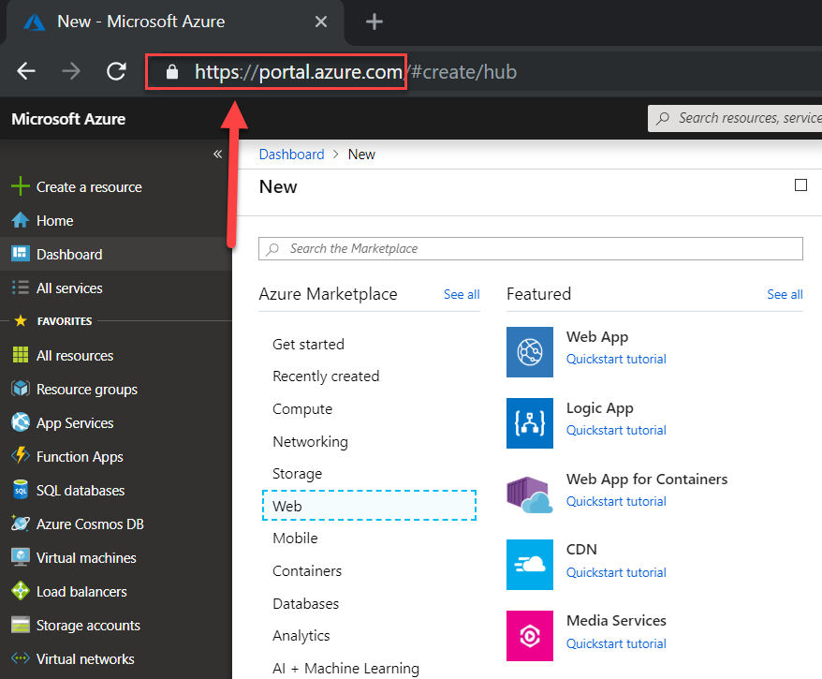

The URL for the Azure portal is [https://portal.azure.com](https://portal.azure.com/)

For more information on the Azure portal, please visit the below URL-

* <https://azure.microsoft.com/en-us/features/azure-portal/>

Parte inferior do formulário

Parte superior do formulário

Pergunta 11: **Correto**

A company needs to store 2 TB worth of data that is infrequently used. The data needs to be accessed via Power BI. Which of the following could be used as a cost-effective data layer for this requirement?

* 

**A. Azure SQL databases**

* 

**B. Azure PostgreSQL**

* 

**C. Azure Cosmos DB**

* 

**D. Azure Data Lake**

**(Correto)**

**Explicação**

**Answer: D**

And then, you can replace the answer text with the following.

If you are looking at storing data that is not frequently used, you can use the Azure Data Lake service.

The Microsoft documentation mentions the following.

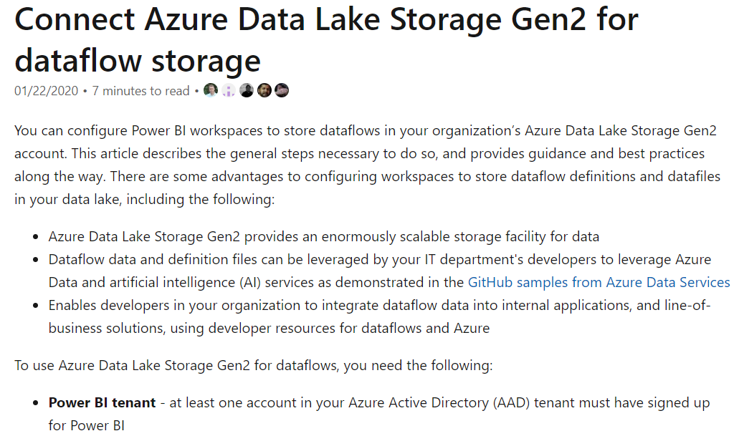

You should use Azure SQL, Azure PostgreSQL, or Cosmos DB for frequently accessed data.

For more detailed information related to the pricing of Azure Data Lake Storage, please visit the following URL-

* <https://azure.microsoft.com/en-us/pricing/details/storage/>

For more information on using Power BI with Azure Data Lake Storage, please visit the following URL-

* <https://docs.microsoft.com/en-us/power-bi/service-dataflows-connect-azure-data-lake-storage-gen2>

Parte inferior do formulário

Parte superior do formulário

Pergunta 12: **Correto**

A company wants to ensure that users in their company are authenticated when they access resources defined in their Azure account. Which of the following is the correct definition of authentication?

* 

**A. This specifies the type of service you can use in Azure.**

* 

**B. This specifies the type of data you can use in Azure.**

* 

**C. This is the act of providing legitimate credentials.**

**(Correto)**

* 

**D. This specifies what you can do in Azure.**

**Explicação**

**Answer: C**

The definition of Authentication and Authorization is given in the Microsoft documentation.

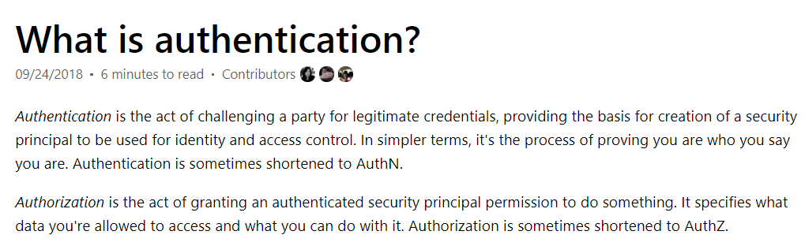

The other options are all incorrect because these are all user cases of Authorization.

For more information on authentication, please visit the below URL-

<https://docs.microsoft.com/en-us/azure/active-directory/develop/authentication-scenarios>

Parte inferior do formulário

Parte superior do formulário

Pergunta 13: **Correto**

A company is planning to create several Virtual Machines in Azure. Which of the following is the right category to which the Azure Virtual Machine belongs?

* 

**A. Infrastructure as a service (IaaS)**

**(Correto)**

* 

**B. Platform as a service (PaaS)**

* 

**C. Software as a service (SaaS)**

* 

**D. Function as a service (FaaS)**

**Explicação**

**Answer: A**

The Microsoft documentation gives an example of the difference between IaaS, PaaS, and SaaS, as shown below.

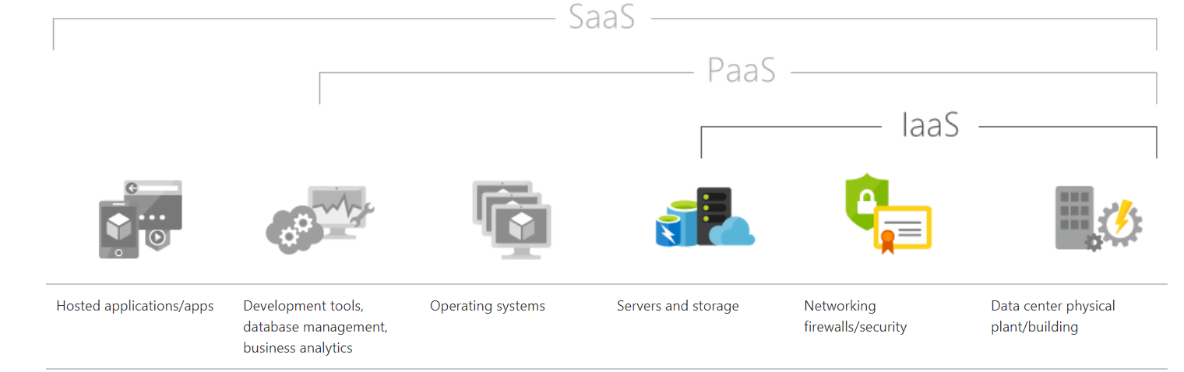

IaaS constitutes the Infrastructure that constitutes your Azure Virtual Machines.

Since this is clearly shown, all other options are incorrect.

For more information on what is IaaS, please visit the below URL-

<https://azure.microsoft.com/en-us/overview/what-is-iaas/>

Parte inferior do formulário

Parte superior do formulário

Pergunta 14: **Incorreto**

A company needs to create around 50 customized Virtual Machines. Out of these only 20 are Windows-based Virtual machines which are identical, and 30 are Ubuntu Machines again of identical configuration. all virtual machines will be used in a load-balanced configuration. Which of the following would help reduce the administrative effort required to deploy the machines?

* 

**A.**

**Azure Load Balancer**

**(Incorreto)**

* 

**B.**

**Azure Web Apps**

* 

**C.**

**Azure Traffic Manager**

* 

**D.**

**Azure ScaleSets**

**(Correto)**

**Explicação**

**Answer: D**

The Microsoft documentation mentions the following.

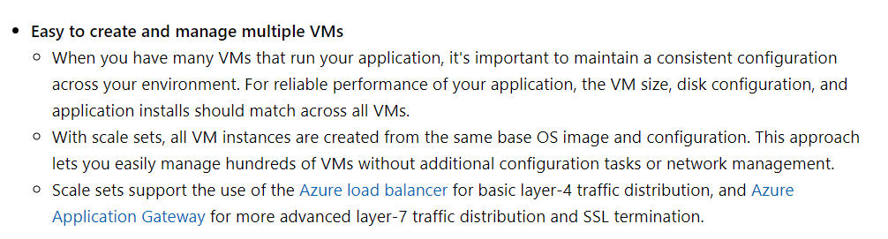

**Option A is incorrect** since this is used to divert traffic to back-end virtual machines at the network layer.

**Option B is incorrect** since it is used to host web applications.

**Option C is incorrect** since this is used for DNS-based traffic routing.

For more information on Virtual Machine Scale sets, please visit the below URL-

<https://docs.microsoft.com/en-us/azure/virtual-machine-scale-sets/overview>

Parte inferior do formulário

Parte superior do formulário

Pergunta 15: **Correto**

A company wants to use Azure for the deployment of various solutions. They want to ensure that whenever users authenticate to Azure, they have to make use of Multi-Factor Authentication. Which of the following can help them achieve this?

* 

**A. Azure Service Trust Portal**

* 

**B. Azure Security Centre**

* 

**C. Azure DDoS protection**

* 

**D. Azure Privileged Identity Management**

**(Correto)**

**Explicação**

**Answer: D**

With Azure Privileged Identity Management, you can use Multi-factor authentication (MFA) to activate any role for users. The Microsoft documentation mentions the following.

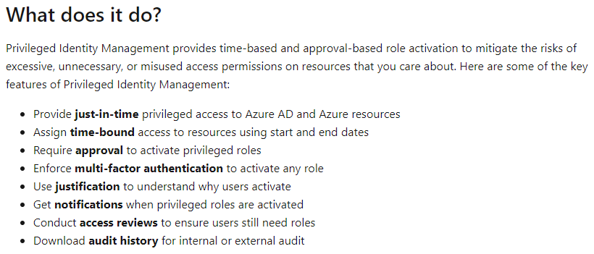

**Option A is incorrect**since Service Trust Portal provides information about Microsoft Cloud services compliance with data protection standards and regulatory requirements, such as the International Organization for Standardization (ISO) **Service** Organization Controls (SOC) National Institute of Standards and Technology (NIST).

**Option B is incorrect** since this is a unified infrastructure security management system in Azure.

**Option C is incorrect** since this is solely a solution to protect against DDoS attacks.

For more information on how to use MFA policies in Azure Privileged Identity Management, please visit the below URL-

<https://docs.microsoft.com/en-us/azure/active-directory/privileged-identity-management/pim-configure>

For more information on MFA and its configuration, please visit the below URL-

<https://docs.microsoft.com/en-us/azure/active-directory/authentication/concept-mfa-howitworks>

Parte inferior do formulário

Parte superior do formulário

Pergunta 16: **Correto**

A company is planning to host 2 Virtual Machines in Azure, as shown below.

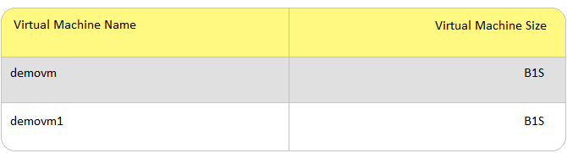

When the virtual machine demovm is stopped, you will still incur costs for the storage attached to the virtual machine. Is this the correct understanding?

* 

**A. Yes**

**(Correto)**

* 

**B. No**

**Explicação**

**Answer: A**

The Disks attached to a Virtual Machine have different costs associated with them.

Below is a screenshot from the pricing calculator for a Virtual Machine. You can see that there is a dependency on the OS Disk.

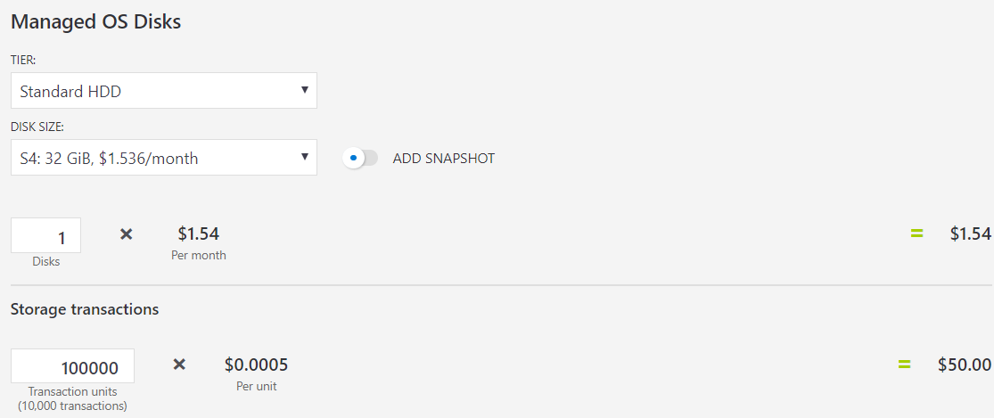

For more information on the pricing calculator, please visit the below URL-

<https://azure.microsoft.com/en-us/pricing/calculator/>

Parte inferior do formulário

Parte superior do formulário

Pergunta 17: **Incorreto**

Which of the following is true when it comes to SaaS (Software as a service)?

* 

**A. You are responsible for scalability of the solution.**

* 

**B. You are responsible for the maintenance of the underlying hardware.**

**(Incorreto)**

* 

**C. You are responsible for configuring the application settings for client-specific customization.**

**(Correto)**

* 

**D. You are responsible for the high availability of the solution.**

**Explicação**

**Answer: C**

Below is a snapshot from the Microsoft documentation on SaaS solutions.

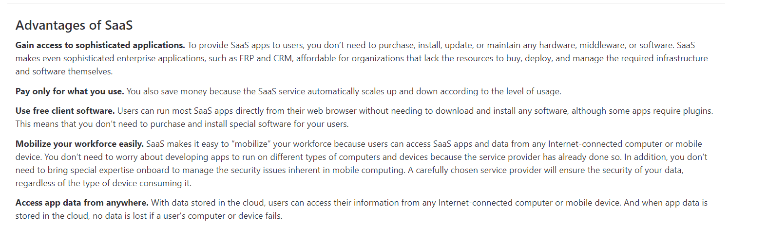

Here you don’t need to worry about the solution itself, the scalability, or availability. You just managed the configuration.

Hence all of the other options are incorrect based on the concept of a SaaS solution.

For more information on SaaS, please visit the below URL-

<https://azure.microsoft.com/en-us/overview/what-is-saas/>

Parte inferior do formulário

Parte superior do formulário

Pergunta 18: **Correto**

A company is planning to set up an Enterprise Azure Subscription. Do they need to have a valid Microsoft Azure account on EA Portal (https://ea.azure.com/) for associating the Azure Subscription?

* 

**A. Yes**

**(Correto)**

* 

**B. No**

**Explicação**

**Answer: A**

When you sign in to an Azure account, you need to sign in with a valid Microsoft account, as shown below.

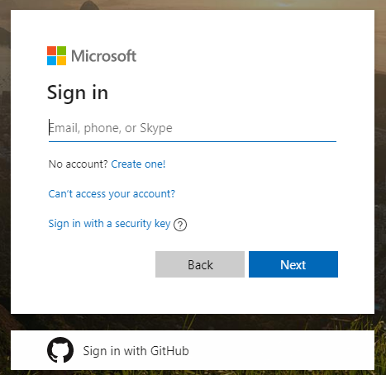

This could be a Work, School or Personal account. The Enterprise Agreement subscription provides a means on how resources get billed for the subscription.

One can contact Microsoft for the Enterprise Agreement via the following URL-

<https://docs.microsoft.com/en-us/azure/cost-management-billing/manage/ea-portal-get-started>

Parte inferior do formulário

Parte superior do formulário

Pergunta 19: **Correto**

An IT administrator for a company has been given a PowerShell script. This PowerShell script will be used to create several Virtual Machines in Azure. You have to provide a machine to the IT administrator for running the PowerShell script.

You decide to provide a Linux machine which has the Azure CLI tools with PowerShell 5.x installed.

Would this solution fit the requirement?

* 

**A. Yes**

* 

**B. No**

**(Correto)**

**Explicação**

**Answer: B**

Azure PowerShell works with PowerShell 5.1 on Windows. On other platforms like Linux, Azure PowerShell 6.2.4 and later versions are compatible. Microsoft recommends PowerShell 7.x and higher on all platforms.

**Azure PowerShell documentation**

Azure PowerShell is a set of cmdlets for managing Azure resources directly from the PowerShell command line. Azure PowerShell is designed to make it easy to learn and get started with but provides powerful automation features. In .NET Standard, Azure PowerShell works with PowerShell 5.1 on Windows by installing some additional modules PowerShellGet & .Net framework.

PowerShell 6.2.4 and later is compatible on all OS platforms. However, Microsoft recommends PowerShell 7.x.

[https://docs.microsoft.com/en-us/powershell/azure/install-az-ps?view=azps-5.4.0](https://docs.microsoft.com/en-us/powershell/azure/?view=azps-4.5.0)

<https://docs.microsoft.com/en-us/azure/virtual-machines/linux/run-command>

Parte inferior do formulário

Parte superior do formulário

Pergunta 20: **Incorreto**

An IT administrator for a company has been given a PowerShell script. This PowerShell script will be used to create several Virtual Machines in Azure. You have to provide a machine to the IT administrator for running the PowerShell script.

You decide to provide a LinuxOS-based machine (with Ubuntu) and use Azure Cloud Shell.

Would this solution fit the requirement?

* 

**A. Yes**

**(Correto)**

* 

**B. No**

**(Incorreto)**

**Explicação**

**Answer: A**

From the Azure Portal, if you use Azure Cloud Shell, you can run both Bash and PowerShell based scripts.

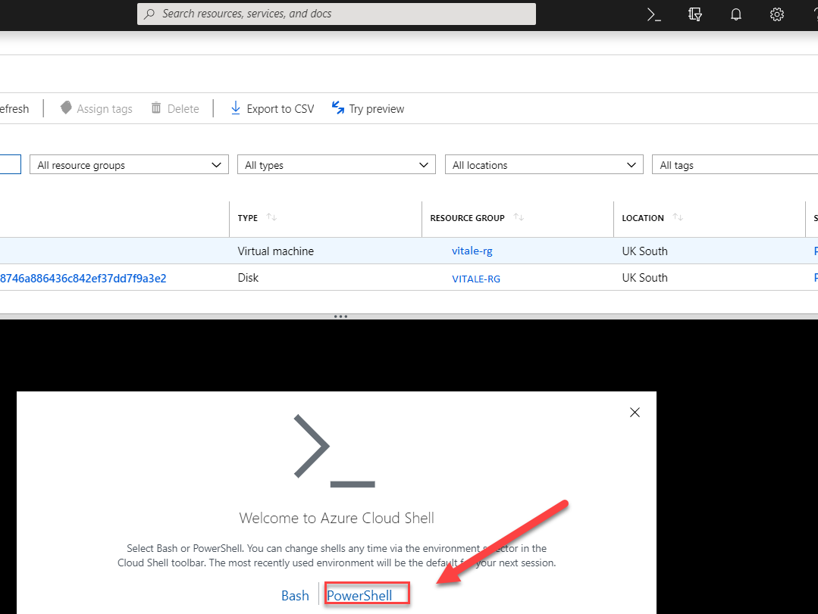

For more information on Azure CloudShell, please visit the below URL-

* <https://azure.microsoft.com/en-us/features/cloud-shell/>
* <https://docs.microsoft.com/en-us/azure/cloud-shell/overview>
* <https://docs.microsoft.com/en-us/azure/cloud-shell/persisting-shell-storage>

Parte inferior do formulário

Parte superior do formulário

Pergunta 21: **Correto**

An IT administrator for a company has been given a PowerShell script. This PowerShell script will be used to create several Virtual Machines in Azure. You have to provide a machine to the IT administrator for running the PowerShell script.

You decide to provide an Azure CLI installed on a computer that has MacOS 10.13 and PowerShell 7.0.3 also installed.

Would this solution fit the requirement?

* 

**A. Yes**

**(Correto)**

* 

**B. No**

**Explicação**

**Answer: A**

Yes, you can install Powershell on MacOS and then run the PowerShell scripts.

For more information on installing PowerShell on MacOS, please visit the below URL-

<https://docs.microsoft.com/en-us/powershell/scripting/install/installing-powershell-core-on-macos?view=powershell-6>

Parte inferior do formulário

Parte superior do formulário

Pergunta 22: **Incorreto**

A company is planning to set up a solution in Azure. The solution would have the following key requirement.

* An Integration solution for the deployment of code

Which of the following would be best suited for this requirement?

* 

**A. Azure Advisor**

**(Incorreto)**

* 

**B. Azure Cognitive Services**

* 

**C. Azure Application Insights**

* 

**D. Azure DevOps**

**(Correto)**

**Explicação**

**Answer: D**

Azure DevOps consists of a large set of tools. Amongst these, you have Azure Pipelines, which can be used to build, test and deploy code.

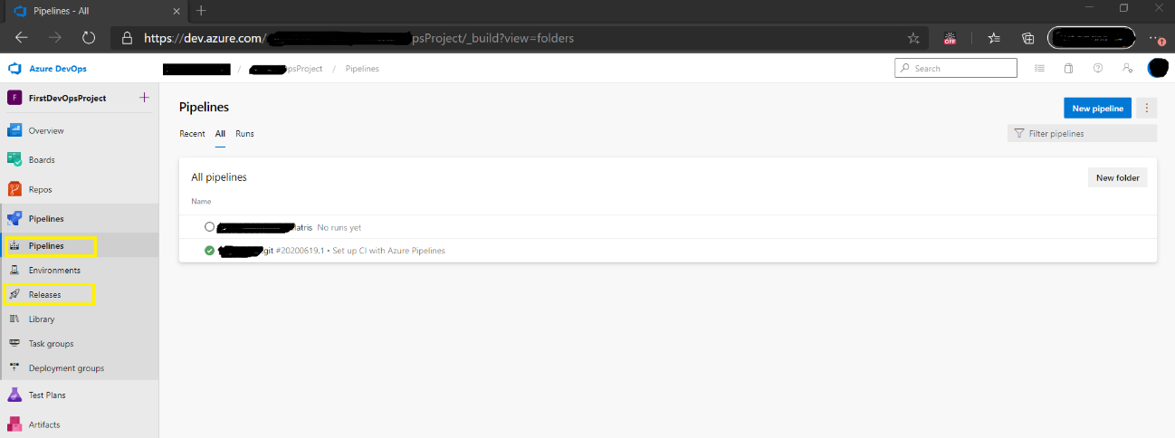

Since this is a clear feature of the tool, all other options are incorrect.

For more information on Azure DevOps, please visit the below URL-

<https://azure.microsoft.com/en-us/services/devops/>

Parte inferior do formulário

Parte superior do formulário

Pergunta 23: **Incorreto**

A company is planning to set up a solution in Azure. The solution would have the following key requirement.

* A tool that provides guidance and recommendations to improve an Azure environment

Which of the following would be best suited for this requirement?

* 

**A. Azure Advisor**

**(Correto)**

* 

**B. Azure Cognitive Services**

**(Incorreto)**

* 

**C. Azure Application Insights**

* 

**D. Azure Devops**

**Explicação**

**Answer: A**

This is clearly mentioned in the Microsoft documentation.

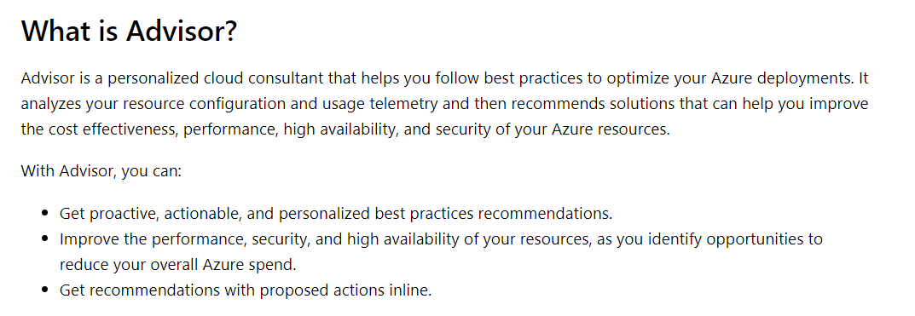

Since this is a clear feature of the tool, all other options are incorrect.

For more information on Azure Advisor, please visit the below URL-

<https://docs.microsoft.com/en-us/azure/advisor/advisor-overview>

Parte inferior do formulário

Parte superior do formulário

Pergunta 24: **Incorreto**

A company is planning to set up a solution in Azure. The solution would have the following key requirement.

* A simplified tool to build intelligent Artificial Intelligence applications

Which of the following would be best suited for this requirement?

* 

**A. Azure Advisor**

**(Incorreto)**

* 

**B. Azure Cognitive Services**

**(Correto)**

* 

**C. Azure Application Insights**

* 

**D. Azure Devops**

**Explicação**

**Answer: B**

As shown in the Microsoft documentation below, the Azure Cognitive services has an entire list of features that can be used to build Artificial Intelligent based applications.

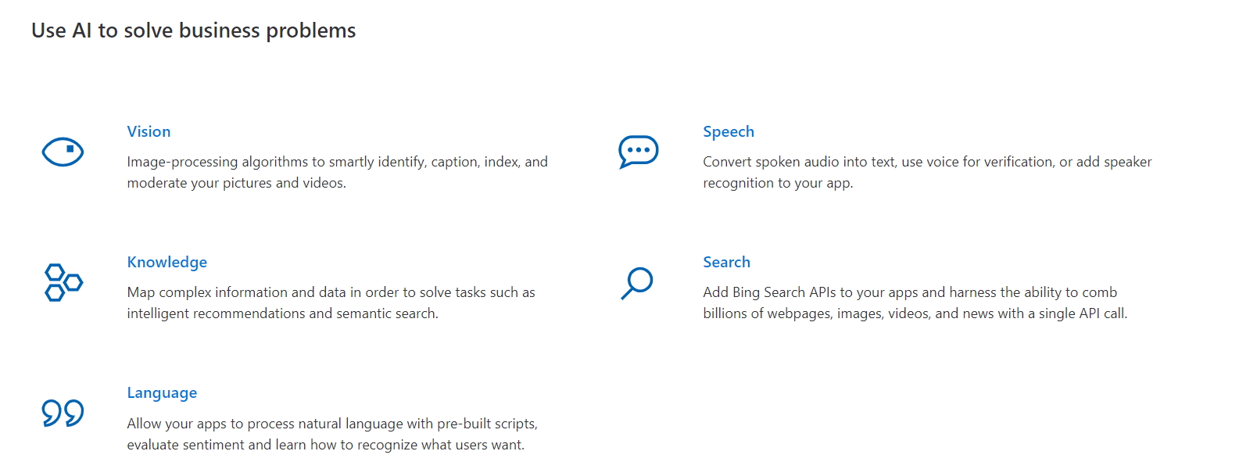

Since this is a clear feature of the tool, all other options are incorrect.

For more information on Azure Cognitive services, please visit the below URL-

<https://azure.microsoft.com/en-us/services/cognitive-services/>

Parte inferior do formulário

Parte superior do formulário

Pergunta 25: **Incorreto**

A company is planning to set up a solution in Azure. The solution would have the following key requirement

* A tool used to monitor Web applications hosted in production-based environments.

Which of the following would be best suited for this requirement?

* 

**A.**

**Azure Advisor**

**(Incorreto)**

* 

**B.**

**Azure Cognitive Services**

* 

**C.**

**Azure Application Insights**

**(Correto)**

* 

**D.**

**Azure Devops**

**Explicação**

**Answer: C**

This is clearly mentioned in the Microsoft documentation.

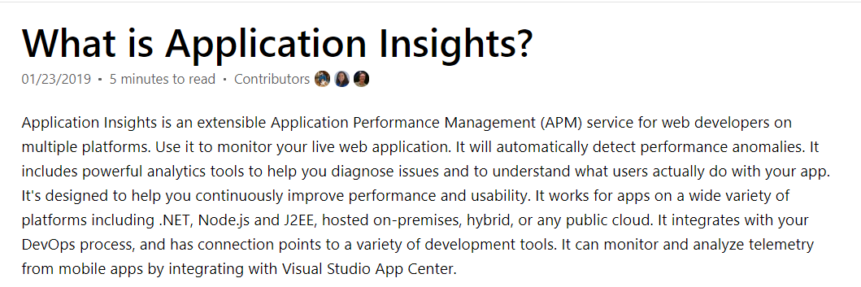

Since this is a clear feature of the tool, all other options are incorrect.

For more information on Azure Application Insights, please visit the below URL-

<https://docs.microsoft.com/en-us/azure/azure-monitor/app/app-insights-overview>

Parte inferior do formulário

Parte superior do formulário

Pergunta 26: **Correto**

A company needs to implement a solution in Azure. Below are the key requirements for this solution.

* No need for schema or Index management
* Ensure low latency access to data from around the world.

Which of the following data solution would you consider for this requirement?

* 

**A. Azure SQL Database**

* 

**B. Azure CosmosDB**

**(Correto)**

* 

**C. Azure SQL Datawarehouse**

* 

**D. SQL Server Stretch database**

**Explicação**

**Answer: B**

The Microsoft documentation mentions the following when it comes to the features of CosmosDB.

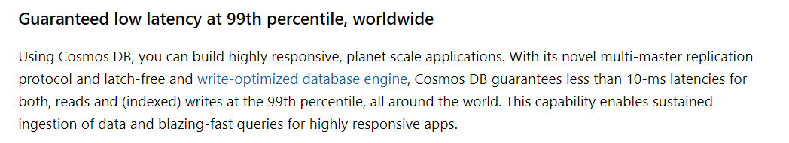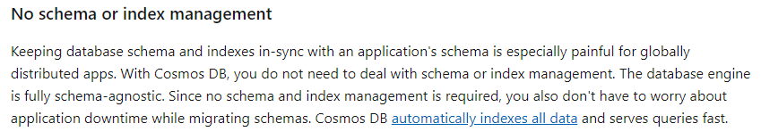

**Option A is incorrect** since this is used to store normal table-like data.

**Option C is incorrect** since this is used for building data warehouses.

**Option D is incorrect** since this is used to stretch warm dynamically and cold transactional data from Microsoft SQL Server 2016 to Microsoft Azure.

For more information on Azure CosmosDB, please visit the below URL-

<https://docs.microsoft.com/en-us/azure/cosmos-db/introduction>

Parte inferior do formulário

Parte superior do formulário

Pergunta 27: **Correto**

A company is planning to deploy Azure resources to a resource group. But the resources would belong to different locations. Can you have resources that belong to the same resource group but be in multiple locations?

* 

**A. Yes**

**(Correto)**

* 

**B. No**

**Explicação**

**Answer: A**

An example is shown below in Azure, where you can have resources in the same resource groups, but in different regions.

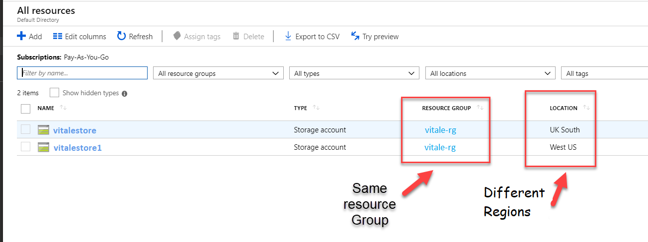

For more information on Azure Resource Manager, please visit the below URL-

* <https://docs.microsoft.com/en-us/azure/azure-resource-manager/resource-group-overview>

Parte inferior do formulário

Parte superior do formulário

Pergunta 28: **Correto**

A company is planning to deploy Azure resources to a resource group. The company is planning to assign tags to the resource groups. Would the resources in the resource group also inherit the same tags?

* 

**A. Yes**

* 

**B. No**

**(Correto)**

**Explicação**

**Answer: B**

An example is shown below where a resource group has a tag defined.

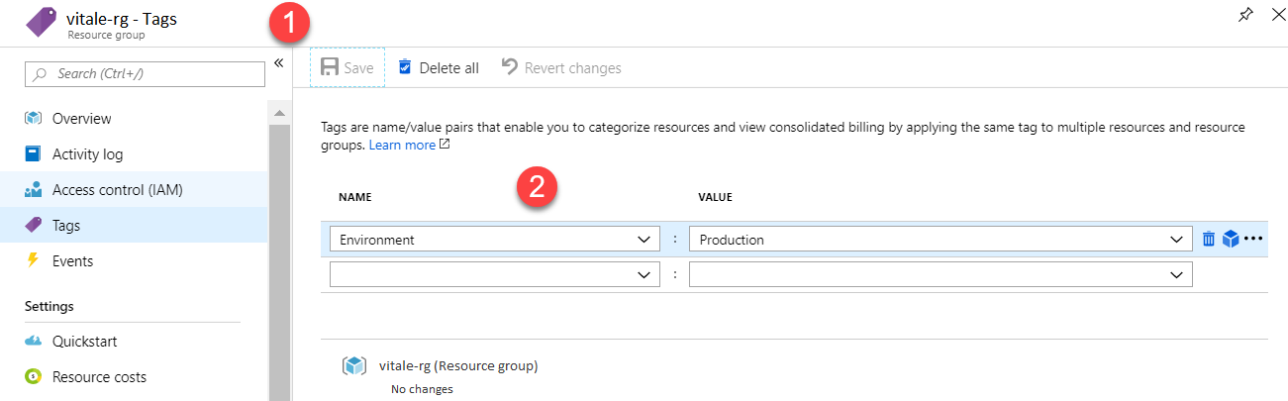

1. And there is a resource defined in the resource group.

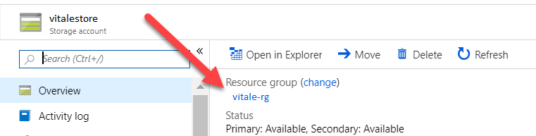

1. If you go to the Tags section of the resource, you will see that there are no tags defined.

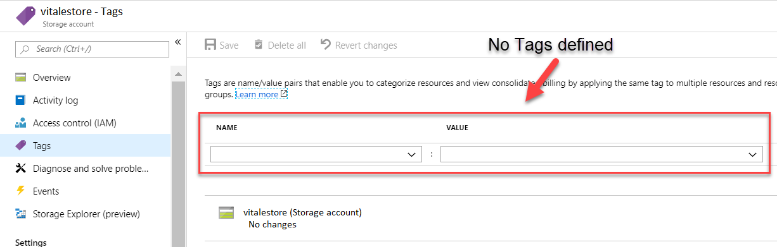

For more information on Azure Resource Group Tags, please visit the below URL-

<https://docs.microsoft.com/en-us/azure/azure-resource-manager/resource-group-using-tags>

Parte inferior do formulário

Parte superior do formulário

Pergunta 29: **Incorreto**

A company is planning to deploy Azure resources to a resource group. The company is planning to assign permissions to the resource groups. Would the resources in the resource group also inherit the same permissions?

* 

**A. Yes**

**(Correto)**

* 

**B. No**

**(Incorreto)**

**Explicação**

**Answer: A**

1. An example is shown below where a resource group has a permission defined.

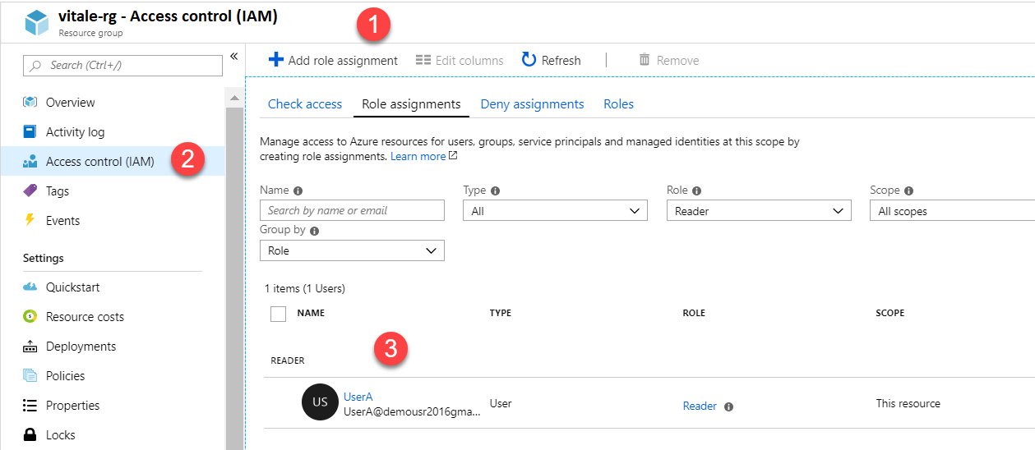

1. And there is a resource defined in the resource group.

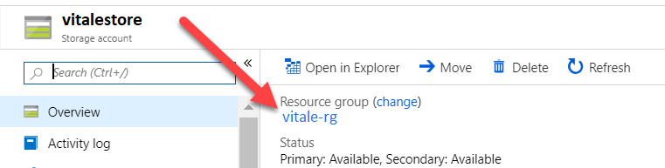

1. If you go to the Access Control section of the resource, you will see that the permissions are inherited from the resource group.

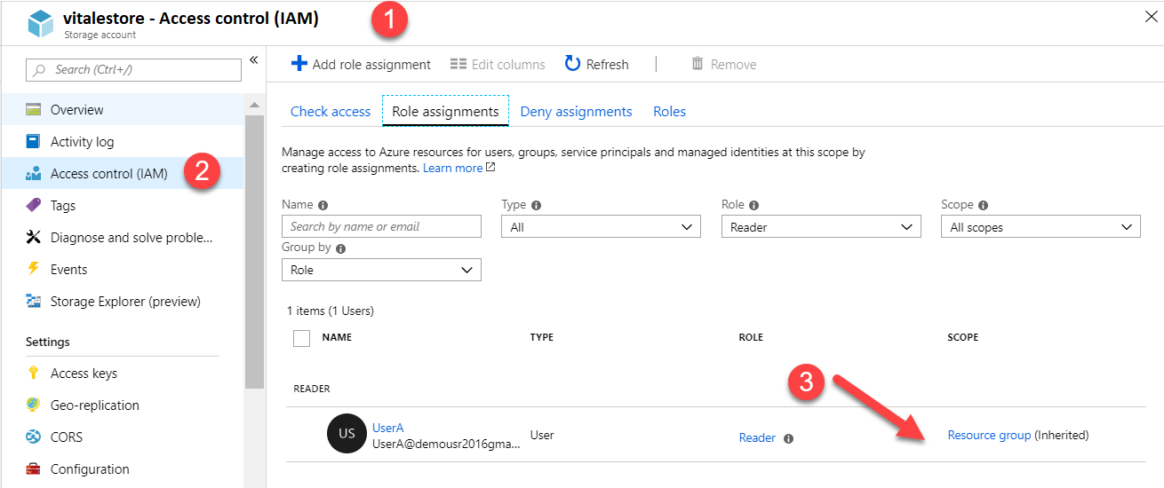

For more information on role-based access control, please visit the below URL-

<https://docs.microsoft.com/en-us/azure/role-based-access-control/role-assignments-portal>

Parte inferior do formulário

Parte superior do formulário

Pergunta 30: **Incorreto**

A company has a set of resources deployed to Azure. They want to use the Azure Advisor tool. Would the Azure Advisor tool alone be able to give recommendations on how to improve the security of the Azure AD environment?

* 

**A. Yes**

**(Incorreto)**

* 

**B. No**

**(Correto)**

**Explicação**

**Answer: B**

The Azure document clearly says that "Azure Advisor integrates with Microsoft Defender for Cloud" to give the security recommendations.

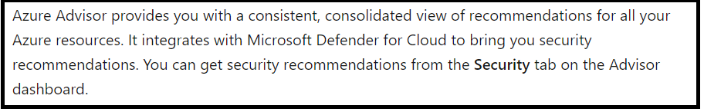

It is also highlighted in the screenshot in the explanation section.

**Therefore the answer is NO.**

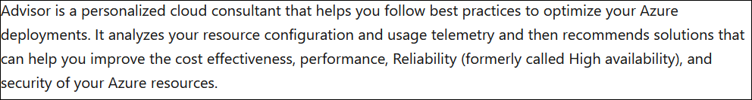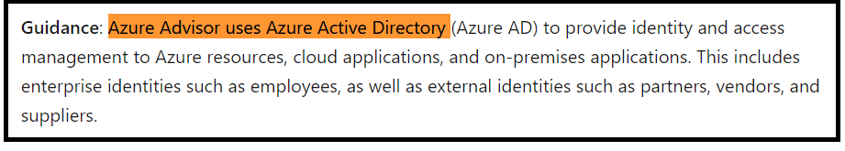

**Reference:**

* <https://docs.microsoft.com/en-us/azure/advisor/security-baseline>
* <https://docs.microsoft.com/en-us/azure/advisor/advisor-security-recommendations>

Parte inferior do formulário

Parte superior do formulário

Pergunta 31: **Correto**

A company has a requirement to deploy 10 Azure resources for several departments. All of the resource types and configurations are the same. Which of the following could be used to automate the deployment of the resources using infrastructure as code?

* 

**A. Azure Resource Manager templates**

**(Correto)**

* 

**B. Virtual machine scale sets**

* 

**C. Azure API Management service**

* 

**D. Management groups**

**Explicação**

**Answer: A**

The Microsoft documentation gives the definition of a template, as shown below.



Resource Manager templates are the ideal solution when you have to deploy the same type of resource repeatedly.

**Option B is incorrect** since this is good only if you need to automate the deployment of Virtual Machines.

**Option C is incorrect** since this is used for making API calls to Azure.

**Option D is incorrect** since this is used to group your resources within subscriptions.

For more information on Resource Manager, please visit the below URL-

<https://docs.microsoft.com/en-us/azure/azure-resource-manager/resource-group-overview>

Parte inferior do formulário

Parte superior do formulário

Pergunta 32: **Incorreto**

A company has hosted its solutions on the Azure Cloud. They need to implement MFA for identities hosted in Azure. Is it necessary to deploy a federation solution for identities available in cloud?

* 

**A. Yes**

**(Incorreto)**

* 

**B. No**

**(Correto)**

**Explicação**

**Answer: B**

There are various ways to implement MFA on Azure, like using Conditional Access policies. In Azure AD, you can also manage MFA settings, as shown below.

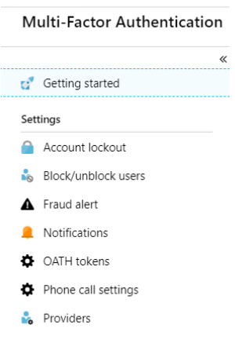

For more information on how to configure MFA settings, please visit the below URL-

* <https://docs.microsoft.com/en-us/azure/active-directory/authentication/howto-mfa-getstarted>
* <https://docs.microsoft.com/en-us/azure/active-directory/authentication/tutorial-enable-azure-mfa>

Parte inferior do formulário

Parte superior do formulário

Pergunta 33: **Incorreto**

A company has deployed their solutions to Azure. They have users that connect to Azure AD via the Internet. They have the requirement that they are prompted to change their password if users try to login from previously unseen IP addresses. Which of the following should the company consider for this requirement?

* 

**A. Azure AD Connect Health**

* 

**B. Azure AD Privileged Identity Management**

* 

**C. Azure Advanced Threat Protection (ATP)**

**(Correto)**

* 

**D. Azure AD Identity Protection**

**(Incorreto)**

**Explicação**

**Answer: C**

This article is updated frequently to let you know what's new in the latest releases of Microsoft Defender for Identity (formerly Azure Advanced Threat Protection, also known as Azure ATP).

For details of earlier Defender for Identity releases until (and including) release 2.55, see the [Defender for Identity release reference](https://docs.microsoft.com/en-us/defender-for-identity/release-reference).

RSS feed: Get notified when this page is updated by copying and pasting the following URL into your feed reader:

https://docs.microsoft.com/api/search/rss?search=%22This+article+is+updated+frequently+to+let+you+know+what%27s+new+in+the+latest+release+of+Microsoft+Defender+for+Identity%22&locale=en-us

Microsoft Defender for Identity (formerly Azure Advanced Threat Protection, also known as Azure ATP) is a cloud-based security solution that leverages your on-premises Active Directory signals to identify, detect, and investigate advanced threats, compromised identities, and malicious insider actions directed at your organization

Defender for Identity enables SecOp analysts and security professionals struggling to detect advanced attacks in hybrid environments to:

* Monitor users, entity behavior, and activities with learning-based analytics
* Protect user identities and credentials stored in Active Directory
* Identify and investigate suspicious user activities and advanced attacks throughout the kill chain
* Provide clear incident information on a simple timeline for fast triage
* 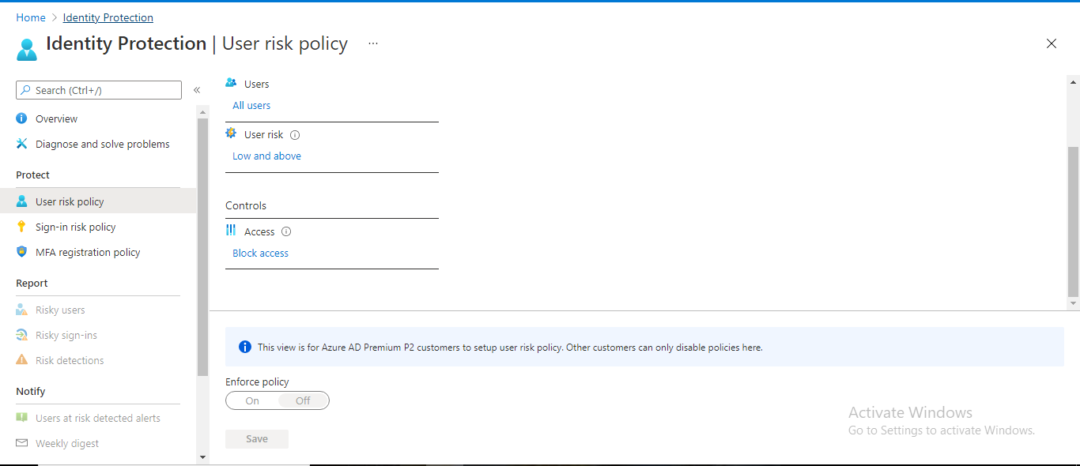
  1. First go to User risk policy
  2. Next go to Controls

Then based on the user sign-in risk condition, you can make the user change the password as per the policy.

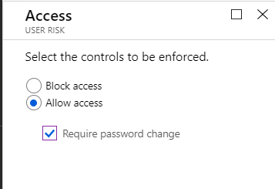

**Option A is incorrect** since this is used to check the health status of Azure AD Connect.

**Option B is incorrect** since it is used for privileged level access in Azure.

**Option D is incorrect** since this is used to create a users in Azure.

For more information on Azure AD Identity Protection, please visit the below URL-

<https://docs.microsoft.com/en-us/azure/active-directory/identity-protection/overview>

Parte inferior do formulário

Parte superior do formulário

Pergunta 34: **Incorreto**

A company plans to set up multiple resources in their Azure subscription. They want to implement tagging of resources in Azure. But they want to ensure that they have to contain a tag with a name of “organization” and value of “whizlabs” when resource groups are created.

You recommend using Azure locks for implementing this requirement.

Would this recommendation fulfil the requirement?

* 

**A. Yes**

**(Incorreto)**

* 

**B. No**

**(Correto)**

**Explicação**

**Answer: B**

Azure locks are used to prevent accidental modification or deletion of resources in Azure.

For more information on Azure locks, please visit the below URL-

<https://docs.microsoft.com/en-us/azure/azure-resource-manager/resource-group-lock-resources>

Parte inferior do formulário

Parte superior do formulário

Pergunta 35: **Correto**

A company plans to set up multiple resources in their Azure subscription. They want to implement tagging of resources in Azure. But they want to ensure that when resource groups are created, they have to contain a tag with the name of “organization” and the value of “vitale.”

You recommend using Azure policies for implementing this requirement.

Would this recommendation fulfill the requirement?

* 

**A. Yes**

**(Correto)**

* 

**B. No**

**Explicação**

**Answer: A**

Yes, you can use Azure policies. For this, there is also an inbuilt policy that can be used, as shown below, to implement tagging for resource groups.

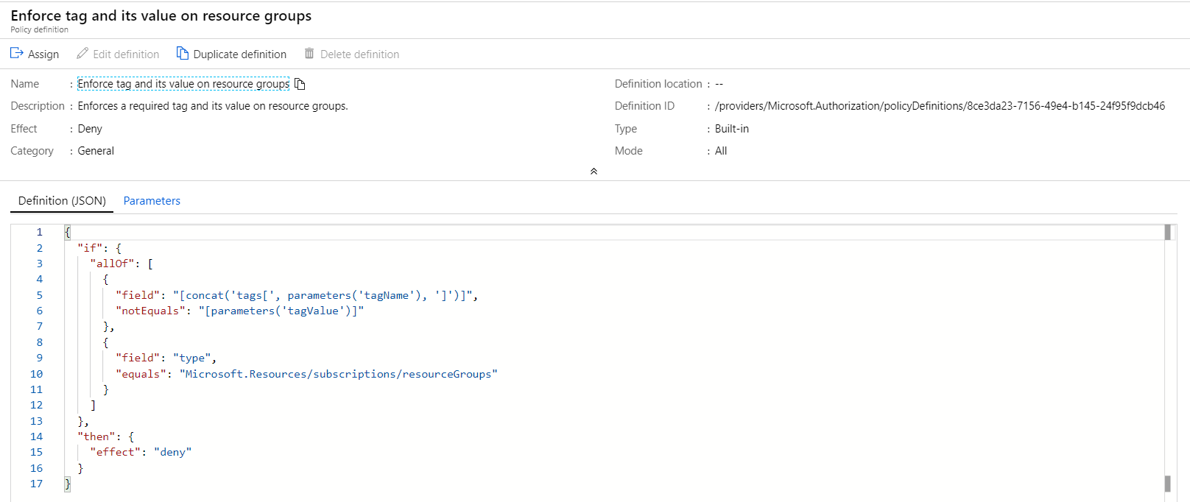

For more information on Azure policies, please visit the below URL-

<https://docs.microsoft.com/en-us/azure/governance/policy/overview>

Parte inferior do formulário

Parte superior do formulário

Pergunta 36: **Incorreto**

A company plans to set up multiple resources in their Azure subscription. They want to implement tagging of resources in Azure. But they want to ensure that when resource groups are created, they have to contain a tag with a name of “organization” and value of “vitale”.

You recommend using Azure Key Vault for implementing this requirement.

Would this recommendation fulfil the requirement?

* 

**A. Yes**

**(Incorreto)**

* 

**B. No**

**(Correto)**

**Explicação**

**Answer: B**

Azure Key vault is used for security purposes such as key and secret management.

For more information on Azure key vault, please visit the below URL-

<https://docs.microsoft.com/en-us/azure/key-vault/key-vault-whatis>

Parte inferior do formulário

Parte superior do formulário

Pergunta 37: **Incorreto**

A company has substantial business-critical utilization of MS Azure. It wants to purchase an Azure support plan. Below is a key requirement from the support plan.

* Provide architectural support for the company’s Azure environment from Pooled Team of Microsoft's ProDirect Delivery Managers.

Which of the following plan would the company need to purchase to fulfil this requirement?

* 

**A.**

**Premier**

* 

**B.**

**Developer**

**(Incorreto)**

* 

**C.**

**Professional Direct**

**(Correto)**

* 

**D.**

**Standard**

**Explicação**

**Answer: C**

From the Support plans, as shown below, you can see that only the Professional Direct plan has the required architecture support.

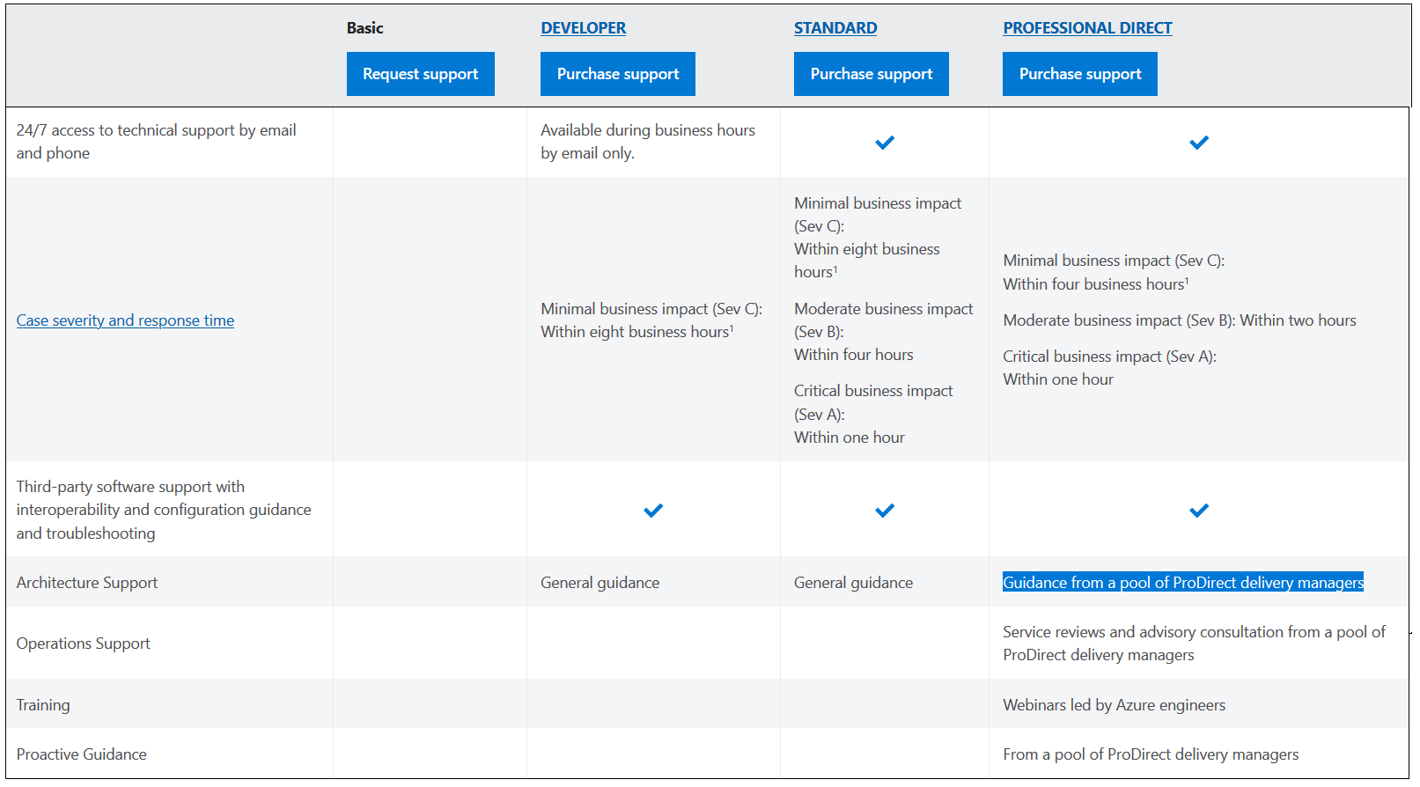

Since this is clear from the documentation, all other options are incorrect.

Note that Microsoft refers to Architectural Support & Guidance as to the same terminology. Refer explanation given on Azure Docs url- <https://azure.microsoft.com/en-us/support/plans/>

as well as the explanation given on Azure Portal.

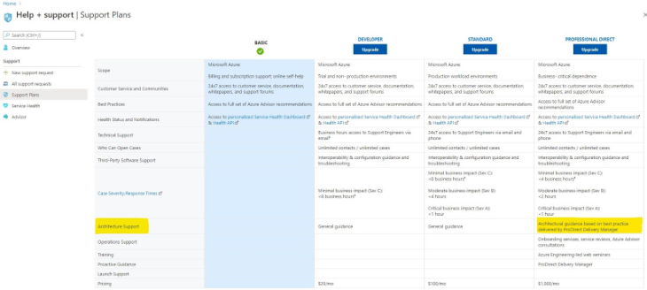

Remember, in the Premier support plan you'll get the added benefit of getting Architecture & Code Review done by MS Technical Account Manager.

<https://azure.microsoft.com/en-us/support/plans/premier/>

Parte inferior do formulário

Parte superior do formulário

Pergunta 38: **Incorreto**

A company has a set of Virtual machines defined in Azure. One of the machines was down due to issues with the underlying Azure Infrastructure. The server was down for an extended period. So it breached the standard SLA defined by Microsoft. How will Microsoft reimburse the downtime cost?

* 

**A. By directly sending money to the customer’s bank account**

* 

**B. By spinning up another Virtual Machine free of cost for the client**

**(Incorreto)**

* 

**C. By providing service credits to the customer**

**(Correto)**

* 

**D. By providing a service free of cost to use for a specific duration of time.**

**Explicação**

**Answer: C**

If you look at the pricing FAQ, you can see that Microsoft offers Service level credits if it does not meet the SLA targets.



Since this is clearly given in the documentation, all other options are incorrect.

For more information on Azure pricing FAQ’s, please visit the below URL-  
  
[https://azure.microsoft.com/en-in/support/legal/sla/summary/  
  
https://azure.microsoft.com/en-in/support/legal/sla/virtual-machines/v1_9/](https://azure.microsoft.com/en-in/support/legal/sla/summary/)

<https://azure.microsoft.com/en-us/pricing/faq/>

Parte inferior do formulário

Parte superior do formulário

Pergunta 39: **Correto**

A company is planning to move to Azure. The senior management wants to get an idea on the cost that would be incurred when hosting resources in Azure.

You recommend using the Azure Cost Management to get the required costing of the resources.

Would this recommendation fit the requirement?

* 

**A. Yes**

* 

**B. No**

**(Correto)**

**Explicação**

**Answer: B**

The Cost Management feature is great to give you a breakdown of the cost once the resources are hosted in Azure. It will not give you an indication of costs that can be incurred when using Azure. Below is a snapshot of Cost Management in Azure.

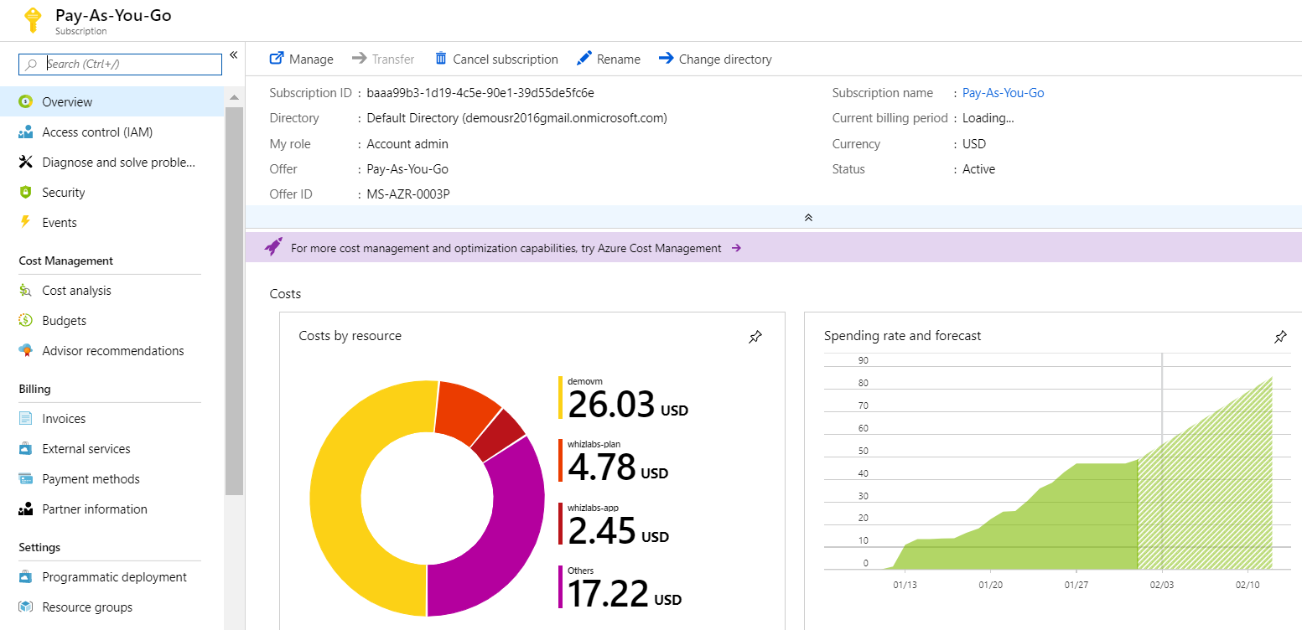

For more information on Azure Cost Management, please visit the below URL-

<https://azure.microsoft.com/en-us/pricing/details/cost-management/>

Parte inferior do formulário

Parte superior do formulário

Pergunta 40: **Correto**

A company is planning to move to Azure. The senior management wants to get an idea on the cost that would be incurred when hosting resources in Azure.

You recommend using the Cloudyn service to get the required costing of the resources.

Would this recommendation fit the requirement?

* 

**A. Yes**

* 

**B. No**

**(Correto)**

**Explicação**

**Answer: B**

No, among the three scenarios **Storage, backup, and recovery**is an IaaS (Infrastructure as a service) use-case.

Organizations typically use **PaaS** for these scenarios:

* Development framework
* Analytics or business intelligence
* Additional services

**IaaS scenarios:**

* Lift-and-shift migration
* Test and development
* Storage, backup, and recovery
* Web apps
* High-performance computing

**References:**

* <https://azure.microsoft.com/en-in/overview/what-is-paas/>
* <https://azure.microsoft.com/en-in/overview/what-is-iaas/#overview>

Parte inferior do formulário

Parte superior do formulário

Pergunta 41: **Incorreto**

The senior management wants to get an idea of the cost that would be incurred when hosting resources in Azure.

You recommend using the pricing calculator to get the required costing of the resources.

Would this recommendation fit the requirement?

* 

**A. Yes**

**(Correto)**

* 

**B. No**

**(Incorreto)**

**Explicação**

**Answer: A**

The pricing calculator is the perfect tool for estimating the price of hosting resources in Azure.

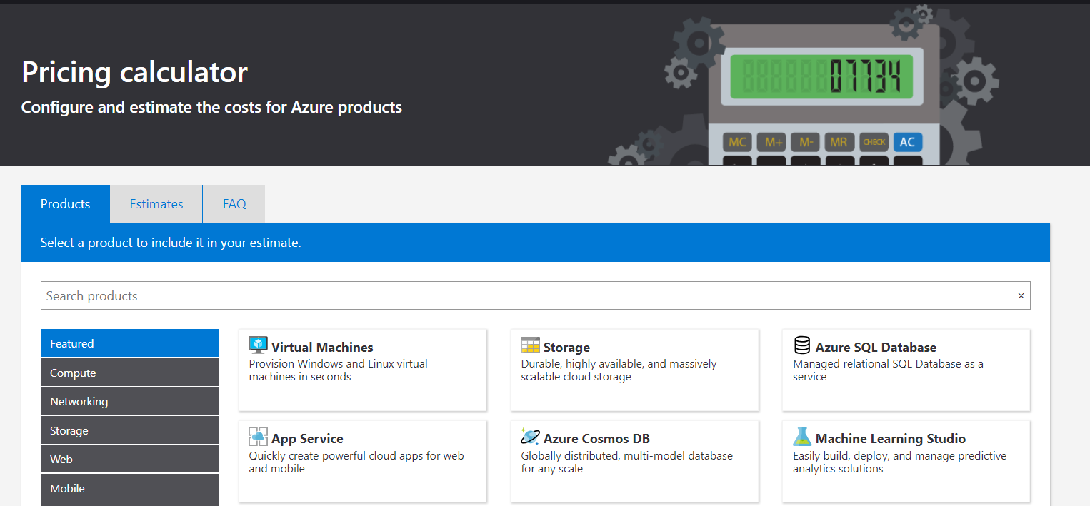

For more information on the Azure pricing calculator, please visit the below URL-

<https://azure.microsoft.com/en-us/pricing/calculator/>

Parte inferior do formulário

Parte superior do formulário

Pergunta 42: **Incorreto**

A company wants to host a mission-critical application on a set of Virtual Machines in Azure. They want to ensure that they can set up the infrastructure in Azure to guarantee the maximum possible uptime for the application. Which of the following can you make use of in Azure to fulfil this requirement? **Choose 2 answers** from the options given below.

* 

**A.**

**Resource Groups**

**(Incorreto)**

* 

**B.**

**Availability Zones**

**(Correto)**

* 

**C.**

**Availability Sets**

**(Correto)**

* 

**D.**

**Resource Tags**

**Explicação**

Answer: **B and C**

The Microsoft documentation mentions the following.

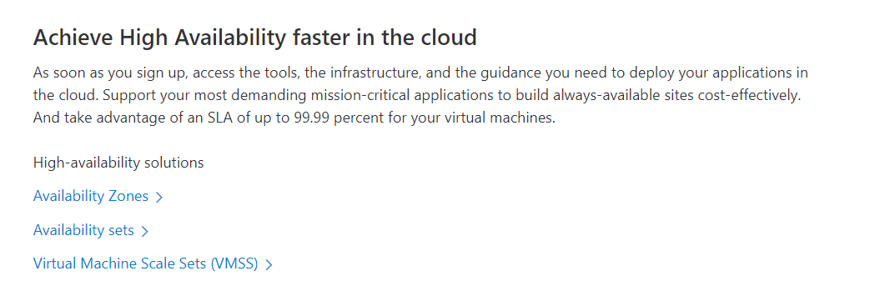

**Option A is incorrect** since this is used to categorize resources.

**Option D is incorrect** since this is used to improve categorization and billing of resources in Azure.

For more information on resiliency in Azure, please visit the below URL-

<https://azure.microsoft.com/en-us/features/resiliency/>

Parte inferior do formulário

Parte superior do formulário

Pergunta 43: **Incorreto**

A company is planning to host an application on a set of Virtual Machines in Azure. They want to ensure that the application recovers from a region-wide failure in Azure. Which of the following concept needs to be considered to fulfil this requirement?

* 

**A. Scalability**

* 

**B. Disaster Recovery**

**(Correto)**

* 

**C. Agility**

* 

**D. Elasticity**

**(Incorreto)**

**Explicação**

**Answer: B**

The Microsoft documentation mentions the following.

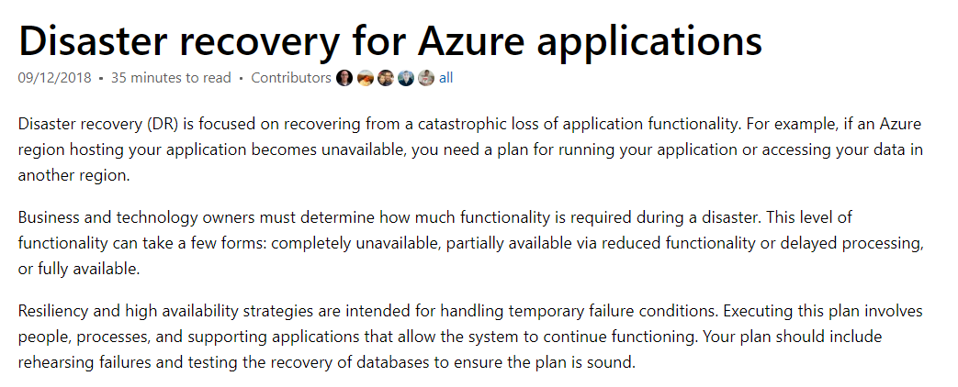

**Option A is incorrect** since this is used to scale in our scale-out infrastructure.

**Option C is incorrect** since this is used from a customer perspective to make applications more agile.

**Option D is incorrect** since this is used to make an application more flexible in its architecture based on user demand.

For more information on disaster recovery in Azure, please visit the below URL-

<https://docs.microsoft.com/en-us/azure/architecture/resiliency/disaster-recovery-azure-applications>

Parte inferior do formulário

Parte superior do formulário

Pergunta 44: **Incorreto**

A company wants to create multiple data stores in Azure. They want to have storage layers that can be used to store data that is infrequently used. Which of the following storage tiers for Azure BLOB storage would be suitable for this type of requirement? **Choose 2 answers** from the options given below.

* 

**A. Premium storage**

* 

**B. Hot storage**

**(Incorreto)**

* 

**C. Cool storage**

**(Correto)**

* 

**D. Archive storage**

**(Correto)**

**Explicação**

**Answer: C and D**

This is given in the Microsoft documentation.

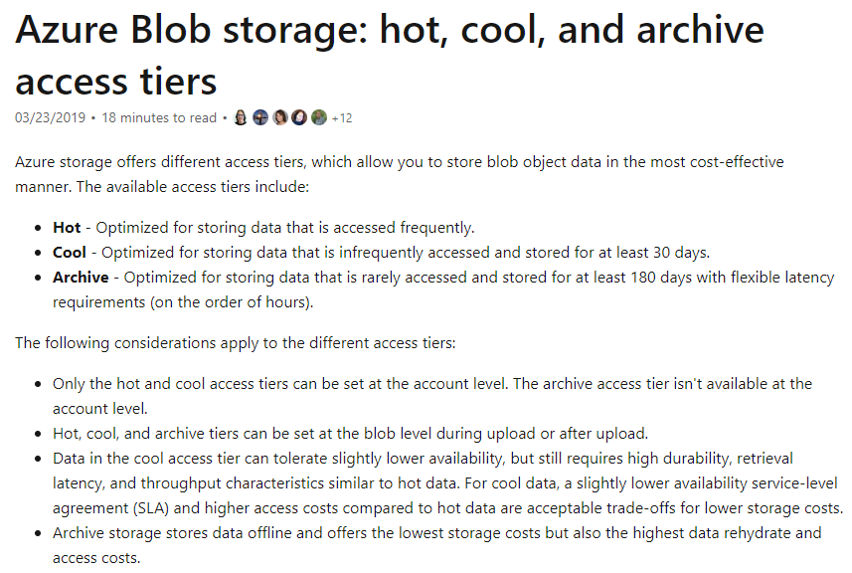

Since this is provided in the Microsoft documentation, all other options are incorrect.

For more information on blob storage tiers, please visit the below URL-

<https://docs.microsoft.com/en-us/azure/storage/blobs/storage-blob-storage-tiers>

Parte inferior do formulário

Parte superior do formulário

Pergunta 45: **Incorreto**

A company is planning to host an application on a set of Virtual Machines. The Virtual Machines are going to be running for a longer period. Which of the following should be considered to reduce the overall cost of Virtual Machine usage?

* 

**A. Premium Disks**

* 

**B. Virtual Machine Scale sets**

* 

**C. Azure Reservations**

**(Correto)**

* 

**D. Azure Resource Groups**

**(Incorreto)**

**Explicação**

**Answer: C**

The Microsoft documentation mentions the following.

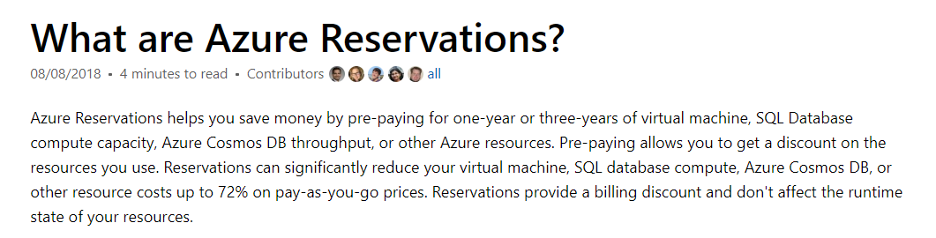

**Option A is incorrect** since using Premium Disks is an expensive option.

**Option B is incorrect** since this is used for scalability of your virtual machines.

**Option D is incorrect** since this is used for grouping your Azure resources.

For more information on Azure Cost Reservations, please visit the below URL-

<https://docs.microsoft.com/en-us/azure/billing/billing-save-compute-costs-reservations>

Parte inferior do formulário

Parte superior do formulário

Pergunta 46: **Incorreto**

A company has launched a set of Virtual Machines in their Pay-as-you-go Azure subscription. After launching a set of VM’s, they seem to be hitting a limit. They cannot provision additional Virtual Machines. Which of the following can be done to allow the company to provision more Virtual Machines?

* 

**A.**

**Raise a support ticket with Microsoft.**

**(Correto)**

* 

**B.**

**Increase the limit in the Azure Monitor.**

* 

**C.**

**Increase the limit using the Azure CLI.**

**(Incorreto)**

* 

**D.**

**Increase the limit in Azure Advisor.**

**Explicação**

**Answer: A**

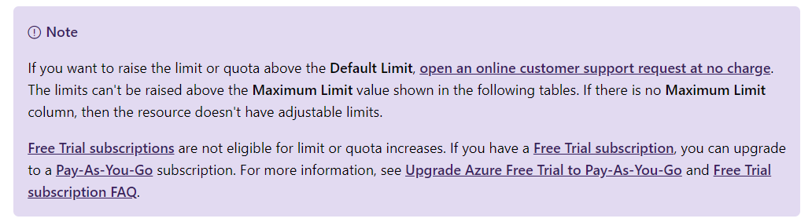

Since this is clearly mentioned in the Microsoft documentation, all other options are incorrect.

For more information on Azure subscription service limits, please visit the below URL-

<https://docs.microsoft.com/en-us/azure/azure-subscription-service-limits>

Parte inferior do formulário

Parte superior do formulário

Pergunta 47: **Incorreto**

A company wants to set up users in its Azure Account. They have segregated their users into groups. They now want to ensure that they set the right privileges for users and administrators accordingly. They need to manage the privileges effectively.

You recommend using Azure Policies.

Does this recommendation meet the requirement?

* 

**A. Yes**

**(Incorreto)**

* 

**B. No**

**(Correto)**

**Explicação**

**Answer: B**

Azure policies are used from more of a governance aspect. The Microsoft documentation mentions the following on Azure policies.

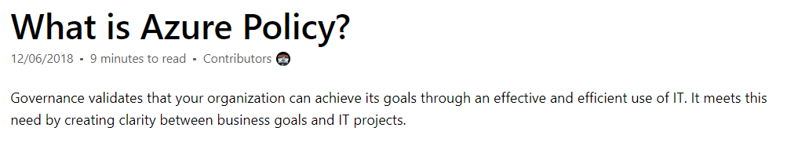

For more information on Azure policies, please visit the below URL-

<https://docs.microsoft.com/en-us/azure/governance/policy/overview>

Parte inferior do formulário

Parte superior do formulário

Pergunta 48: **Incorreto**

A company wants to set up users in their Azure Account. They have segregated their users into groups. They now want to ensure that they set the right permissions for users and administrators accordingly. They need to manage the permissions effectively.

You recommend using Azure Role-Based Access.

Does this recommendation meet the requirement?

* 

**A. Yes**

**(Correto)**

* 

**B. No**

**(Incorreto)**

**Explicação**

**Answer: A**

This is the right way to manage permissions. The Microsoft documentation mentions the following on Role-Based Access control.

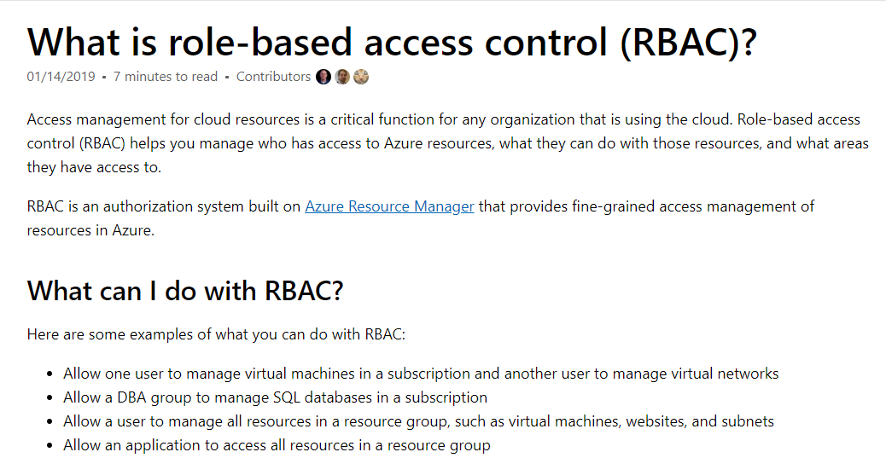

For more information on Role-based access control, please visit the below URL-

<https://docs.microsoft.com/en-us/azure/role-based-access-control/overview>

Parte inferior do formulário

Parte superior do formulário

Pergunta 49: **Correto**

A company wants to set up users in their Azure Account. They have segregated their users into groups for their different Azure Subscriptions that they own. They now want to ensure that they set the right permissions for users and administrators accordingly. They need to manage the permissions effectively.

You recommend using Azure Management Groups.

Does this recommendation meet the requirement?

* 

**A. Yes**

**(Correto)**

* 

**B. No**

**Explicação**

**Answer: A**

Azure management groups are used for organizing resources in Azure. The Microsoft documentation mentions the following on Azure management groups.

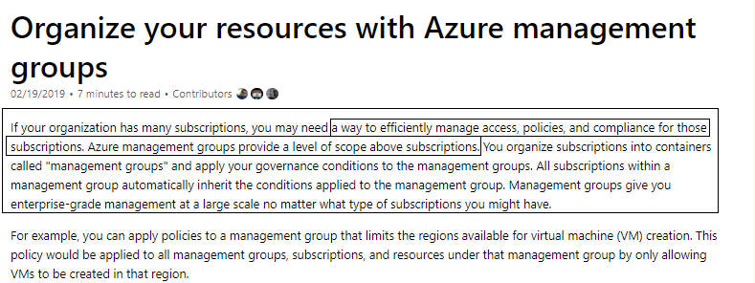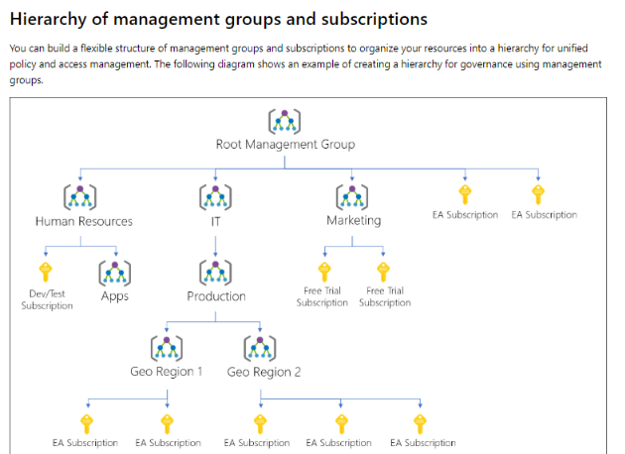

For more information on Azure Management Groups, please visit the below URL-

<https://docs.microsoft.com/en-us/azure/governance/management-groups/>

Parte inferior do formulário

Parte superior do formulário

Pergunta 50: **Correto**

A company wants to host its applications on Azure using serverless components. They don’t want to manage the underlying infrastructure for the application.

Which of the following could be used to host code that could be run on a serverless infrastructure?

* 

**A. Azure Logic Apps**

* 

**B. Azure Service Bus**

* 

**C. Azure Function**

**(Correto)**

* 

**D. Azure Storage**

**Explicação**

**Answer: C**

The Microsoft documentation mentions the following.

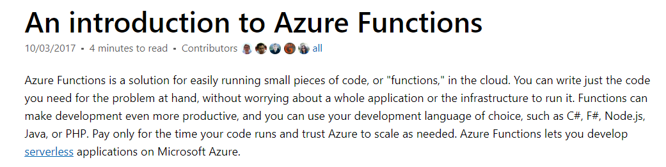

**Option A is incorrect** because this is designed to implement workflows in Azure.

**Option B is incorrect** because this is used as a messaging service in Azure.

**Option D is incorrect** because this is used as a storage service in Azure.

For more information on Azure Functions, please visit the below URL-

<https://docs.microsoft.com/en-us/azure/azure-functions/functions-overview>

Parte inferior do formulário